Mr. Ashley
Art Foundations
Understanding Proportion
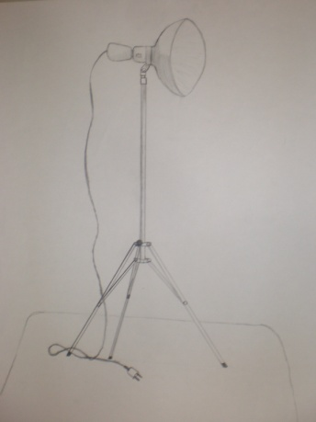

Question: What is Proportion?
Answer: Proportion is the system that allows us to accurately represent whatever it is we are drawing or sculpting.
Question: Why is it Important?
Answer: As soon as you understand how to utilize proportion everything that you do in the visual arts will be remarkably easier and looks better.
The goal of this assignment is to complete two drawings over the course of two class periods. We are going to draw one of our studio lamps which is ideal because it is mostly strait lines. For the first attempt of this drawing I will ask you to work without an introduction to proportion. This will let me see where you are in your drawing process as well as give us something to compare the second drawing to.
Things to consider:
- This first of the two drawings is not about making the perfect image. Erase as much as you need, change things around, and don’t worry about making mistakes. Just do your best work.
- Your drawing of the light should take up the whole page. Get used to drawing on a larger scale.
Assessment:
- Daily Participation
- Accuracy of the second drawing
- Discussion following the project

What people have done in the past:

