Mr. Ashley
Art Foundations
Wire Figure Sculpture
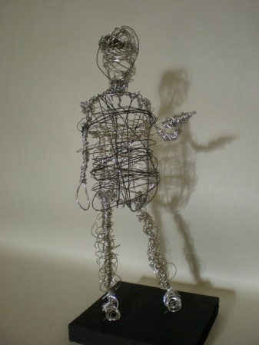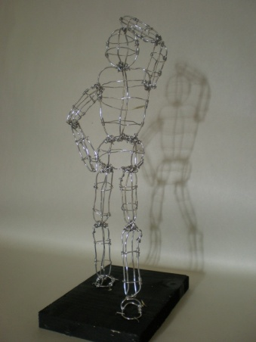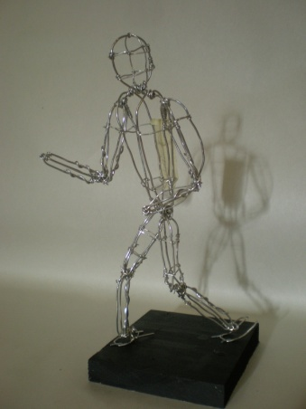

We are going to create a figural sculpture from wire based on the gesture drawings we completed last week. The above images are examples of student work from previous years that met the requirements and received an A on the assignment. Over the course of the next 3-4 days we will construct a wire sculpture, cut and paint a wooden base for the figure to stand on, and attach the figure to that base.
The criteria for the assignment is as follows.
- Each sculpture must be no less than 6 inches tall and no greater than 10.
- The sculpture you create must represent one of the gesture drawings we completed.
- You must demonstrate craftsmanship in your sculpture. (Clean connections of your wire, clean painting of the wooden base, carefully connected sculpture)
- The sculpture must be relatively proportionate.
Assessment
- Craftsmanship
- Daily Participation (On a Scale of 0-4)
- Response to the completed project (either written or verbal)
Take your time on this sculpture, the more careful you are in its creation the easier it will be and the higher your grade will be.

